**Project Documentation: Restaurant Management Application**

**Project Overview :**

The **Restaurant Management Application** is a web-based admin tool designed to help restaurant administrators manage essential details about their restaurants. It provides a user-friendly interface for adding, updating, and deleting restaurant information while displaying the details in a structured and visually appealing format using Bootstrap components.

**Technologies Used :**

1. **Frontend**:
   * **React**: For building the dynamic user interface.
   * **Bootstrap**: For responsive and styled components (form, buttons, cards).
   * **Axios**: For making HTTP requests to the backend.
2. **Backend**:
   * **Node.js**: For creating API endpoints.
   * **Express.js**: For routing and handling server-side logic.
3. **Database**:
   * **MongoDB**: For storing restaurant data.
4. **Development Tools**:
   * **Vite**: For fast development server and building the project.
   * **Thunder Client**: For testing API endpoints.

**Features**

1. **Add Restaurant**:  
   Admins can input restaurant details such as name, location, rating, and top food and save them to the database.
2. **View Restaurants**:  
   All restaurant details are displayed dynamically in styled Bootstrap cards.
3. **Update Restaurant**:  
   Admins can update the location of a specific restaurant by entering a new location.
4. **Delete Restaurant**:  
   Admins can remove a restaurant's data from the database with a single click.
5. **Real-Time Updates**:  
   Changes made by the admin (add, update, or delete) are immediately reflected in the UI.

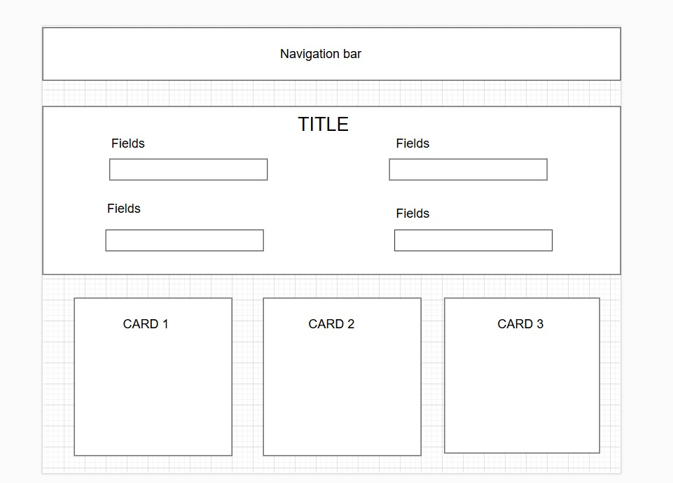**Layout Design using draw.io :**

**How It Works**

1. **Admin Actions**:
   * Admin enters restaurant details in a Bootstrap-styled form.
   * Clicks "Add to List" to save the data to the database.
2. **Data Retrieval**:
   * The app fetches restaurant details from MongoDB using the backend API and displays them in cards.
3. **Edit/Delete Operations**:
   * Admin can update a restaurant’s location or delete a restaurant using respective buttons on each card.

**Use Case :**

The **Restaurant Management Application** is tailored for administrators who need a quick and efficient way to manage restaurant data. It can be used by:

* Restaurant chain managers to oversee multiple branches.
* Admins who wish to update restaurant details frequently.
* Organizations that need to store, update, or remove restaurant records efficiently.